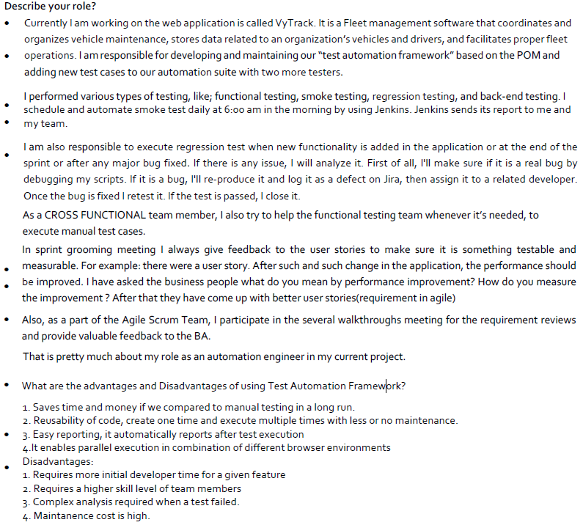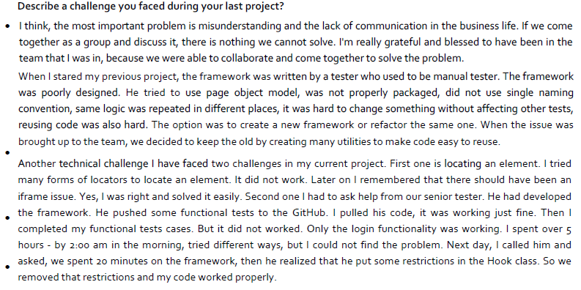

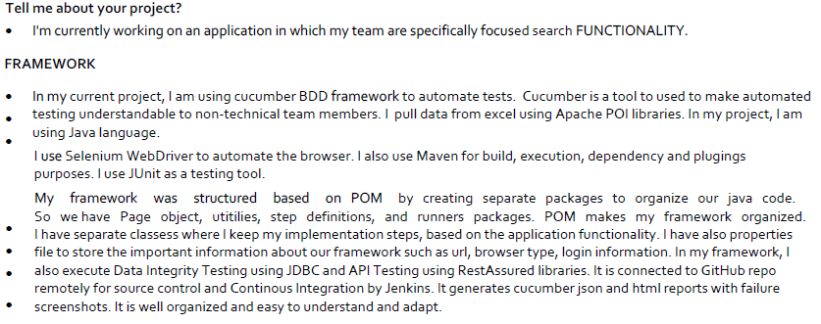

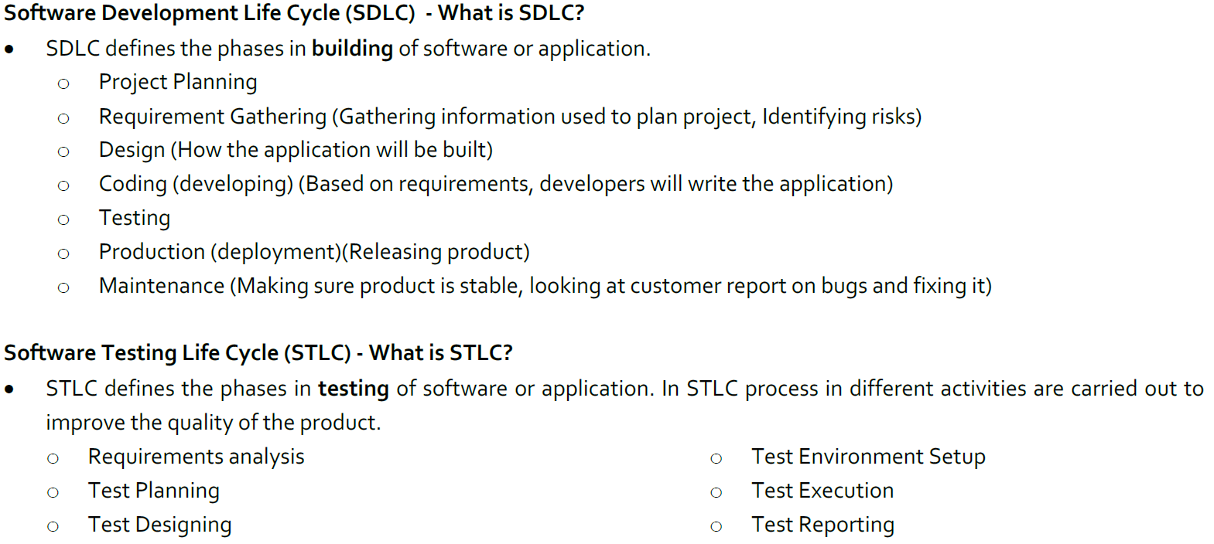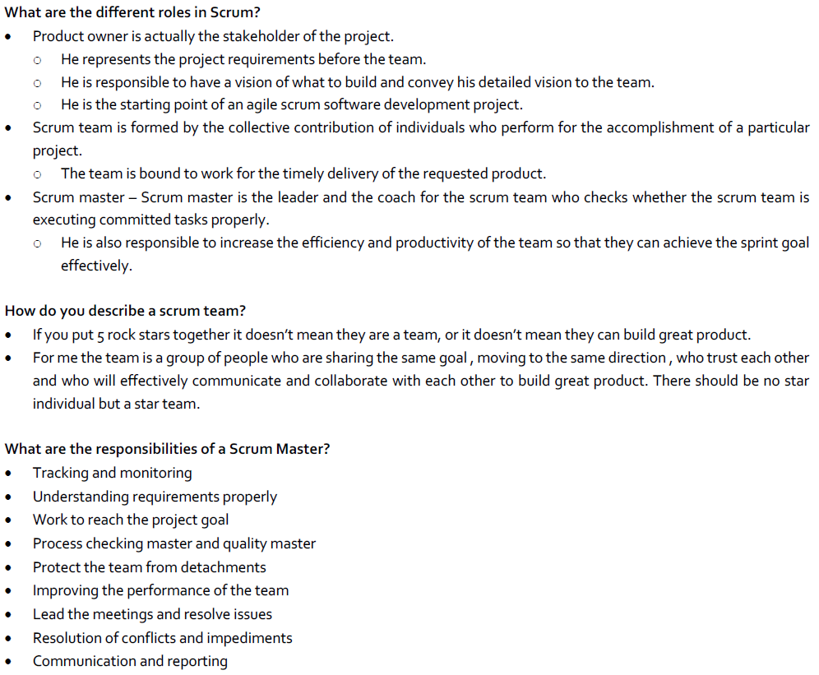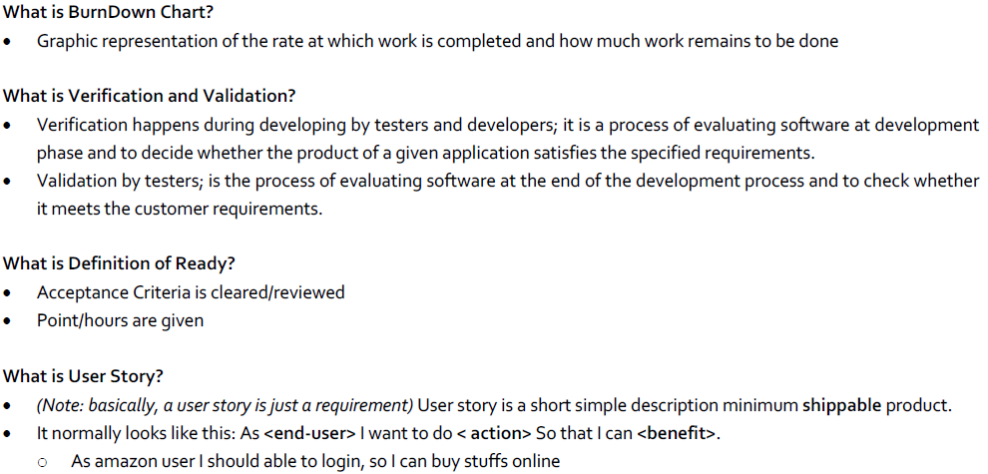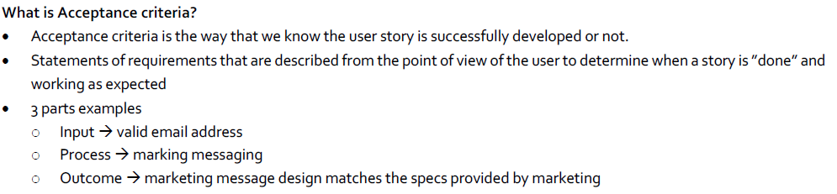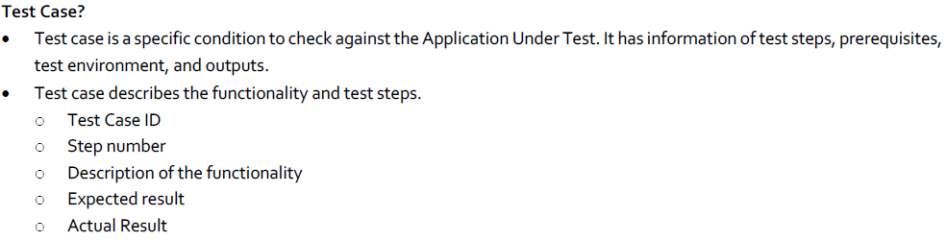

Performance testing is done to provide stakeholders with information about their application regarding speed, stability and scalability. More importantly, performance testing uncovers what needs to be improved before the product goes to market.

Sogeti is the Technology and Engineering Services Division of Capgemini. The Sogeti Group is an information technology consulting company specializing in local professional services, with headquarters in Paris, employing around 25,000 people at around 300 branches in 15 countries.

Why we should hire you:Intellectual curiosity, humility, accountability and positive approach